4D3N HANOI – HALONG

DAY 1: HANOI – ARRIVAL ( D )
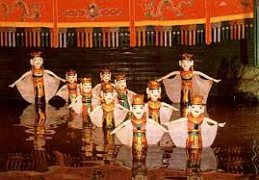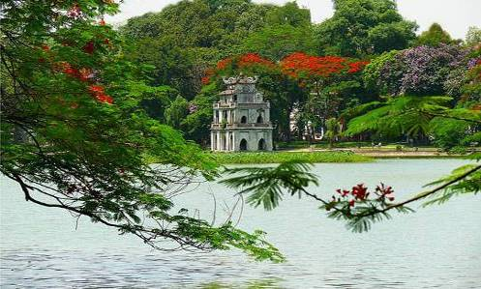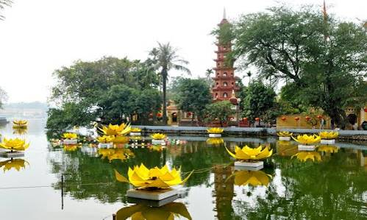
Water Puppet Show Hoan Kiem Lake Tran Quoc Temple
Upon arrival at Noi Bai International airport, transfer to Hanoi downtown to visit the West Lake, Tran Quoc Pagoda, Hoan Kiem Lake (Restored Sword Lake ) and shopping at 36 Old Quarter, enjoy Water Puppet Show.

Meals: 1 Dinner
Accommodation: Overnight in Hanoi.
The distance: Noi Bai Airport – Hanoi Capital: 35km – 45 minutes for transfer.

DAY 2: HANOI – HALONG ( B/L/D)
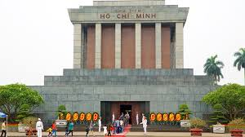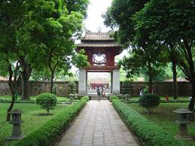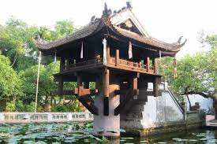
Ho Chi Minh Mausoleum Temple Of Literature One Pillar Pagoda
Breakfast at hotel, starting city tours with Ho Chi Minh Mausoleum, Ho Chi Minh Palace, Ba Dinh Square, Uncle Ho' Stilt House, One Pillar Pagoda, Temple Of Literature. After lunch, transfer to Halong Bay - a UNESCO World Heritage site (160km driving one way - 3.5hrs drive). This will be your first opportunity to see some of the rural areas of Vietnam. The drive goes through the Red River delta, so we'll have plenty of chance for taking photo of Vietnamese farmers tilling the vast green paddy field. Arrival Halong, check in hotel for leisure.
Shopping Stop in Hanoi: Viet Ky Shop ( Local product & Souvenir )

Meals: 1 Breakfast + 1 Lunch + 1 Dinner
Accommodation: Overnight in Halong
The distance: Hanoi – Halong Bay: 160km – 4 hours for transfer & break time on the way.

DAY 3: HALONG – HANOI (B/L/D)
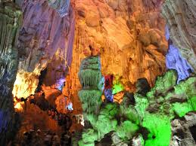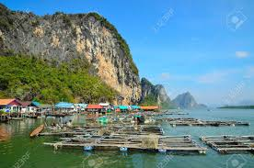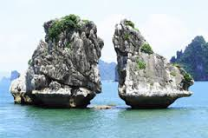
Paradise Grotto Fisherman Village Kissing Chicken Rock

After breakfast, transfer to Halong Boat station to take our private boat to visit the world Heritage Halong Bay about 4 hours, our boat will bring us to visit Paradise Grotto, Kissing Chicken Rock, Fisherman Village, lunch will be served with fresh Halong Seafood, enjoy Vietnam Coffee on Cruise. Transfer back to Hanoi, visit French Opera House.
Shopping Stop in Halong: Tan Sinh The (Rubber & Bamboo Products) or Ngoc Rong Shop (Jewellery Center)

Meals: 1 Breakfast + 1 Lunch + 1 Dinner
Accommodation: Overnight in Hanoi
The distance: Halong Bay - Hanoi : 160km – 4 hours for transfer & break time on the way

DAY 4: HANOI DEPARTURE (B)
Breakfast at hotel, free at leisure, then transfer to airport for flight home with sweet memories.

Meals: 1 Breakfast
The distance: Hanoi Capital - Noi Bai Airport : 35km – 45 minutes for transfer.
The ends of program!

SEQUENCE OF ITINERARY SUBJECT TO LOCAL ARRANGEMENT

PRICE INCLUDE:
- Accommodation – as hotel in the list or similar – based on Twin/Double/Triple sharing.
- Tour guide: English or Chinese speaking guide during the tour.
- Daily ABF and meals as mentioned in the program.
- Shows and sightseeing in schedule.
- Transportation by private air-conditioner.
01 bottle ( 500 ml )of drinking water for each pax per day.
- Meals (Vietnamese Food & Chinese Food) as the tour code (B: Breakfast, L: Lunch, D: Dinner) 8-10 USD/meal/pax + one buffet at Sen Tay Ho Restaurant.
- Free coke/beer/coffee/water on Halong Cruise.
- Boat fees private one in Halong as mentioned in the program.
PRICE EXCLUDE:
- International / Domestic flight ticket & airport tax (if have).
- Personal expenses: Tel, Fax, Mini Bar, Laundry,etc.
- Personal travel insurance
- Compulsory Tip for local guide and driver (USD/pax/day)

Group Size | Tips in USD
2 – 4pax | 6
5-7pax | 5
8 - up | 3

- Surcharge with other languages guide.
- Additional Meal will be surcharge 10usd/pax/meal.
- Surcharge at hotel case by case
  - Chinese New Year (TBA)
  - Gala Dinner on X’Mas (24, 25 Dec ) & New Year 31 Dec

Hotel listed or Similar |  | All rates are next in USD/PAX  valid Jan – Dec, 2020
 |  | Tour by private car / bus with private guide
HANOI | HALONG | 2 | 3-4 | 5-6 | 7-9 | 10-12 | 13-15 | 15+1 | 20+1 | 25 +1 | 30+1 | Sgl up
Larosa 3*  Pomihoa 3*  First Eden 3*  Thang Long Espana 3*  Adamas 3*  Authentic 3* | Seastar 3*  Golden Bay Ha Long 3*  Sen Hotel 3* | 341 | 293 | 246 | 228 | 221 | 208 | 203 | 196 | 190 | 186 | 70
Thang Long Opera 4*  Chalcedony 4  Hotel Kuretakeso 4*  Lan Vien 4* | Galaxy Ha Long 4*  Au Lac 4*  Mithrin 4*  Song Loc 4* | 369 | 321 | 273 | 258 | 248 | 230 | 226 | 218 | 213 | 208 | 98

NOTE

The timing of sightseeing points shall be fixing by local operator due to traffic and weather conditions, however all points must cover unless amendment or cancellation make by clients themselves (Non-refundable for any cancellation that made by clients)

Tour and price are subject to change without notice or incase of deduct number of pax in quoted group.

Small deviations in the tour program are sometimes necessary, depending on weather, road conditions, flight schedules and room availability.

Supplement charge for room rate in peak dates depends on the hotel category used. Compulsory gala dinner on X’mas, New Year’s Eve & Lunar New Year’s Eve to be advised upon booking. Prices for group of 15 persons up in 5 stars hotels sometime requires to re-quote bases on the hotel policy

01 FOC for tour leader based on twin sharing basis include breakfast (domestic air ticket is not applicable).

BUS

Group Size | Kind of Transportation
1-2 pax | 4 seater
3 pax | 7 seater
4-9pax | 16 seater
10-18 pax | 30 seater
19-21 pax | 35 seater
22 – 42 pax | 45 seater

OPTIONAL INFO:

1/ Trishaw to visit 36 old quarters 10 USD/1 pax/ 1 trishaw.
2/ Vietnamese traditional massage in Halong bay: 1h30 minutes including tips: 20 USD/ pax.

- Commisstion 10% for tour leader

SHOPPING INFO:

1/ Vietnam local products
2/ Duty free jewelry center

- Commision 5% for Tour Leader

Tour request without shopping and no options will be surcharge 10USD/pax.

CHILD POLICY

- Infant below 2 years old sharing same room with parents is free of charge.
- Child below 12 yrs old sharing same room with 1 ADL is charged for 90%.
- Child below 12 yrs old with extra bed and sharing same room with parents is charged for 65%.
- Child below 12 yrs old No extra bed & sharing same room with parents is charged for 55%.

